Unit-4: INSTANT BASED LEARNING
Name: S. Sri Sai Prasanna Durga
Reg No: 192424241
Course Code: ITA0601-Machine Learning
Title: SOIL FERTILITY CLASSIFICATION USING K-NEAREST NEIGHBOUR (KNN) FOR IMPROVING CROP PRODUCTIVITY
Related Sustainable Development Goal (SDG)
SDG 2 – Zero Hunger
1. Abstract:
Agriculture plays an important role in ensuring food security and supporting sustainable development. Soil fertility is one of the major factors affecting crop growth and agricultural productivity. The fertility of soil depends on several characteristics such as nitrogen, phosphorus, potassium and pH. Correctly identifying soil fertility levels can help in selecting suitable crops and applying appropriate soil management practices.
This project develops a K-Nearest Neighbour (KNN) machine learning model to classify soil fertility into different categories such as Low, Medium and High. A soil fertility dataset containing soil nutrient and pH information is used for the analysis. The dataset is loaded and processed using Python and Pandas. Missing values are handled before model development. The input features are standardized using StandardScaler because KNN is a distance-based algorithm.
The dataset is divided into training and testing data. A KNN classification model is then trained using the training dataset and used to predict the fertility level of unseen soil samples. The performance of the model is evaluated using accuracy, precision, recall and F1-score. A visualization of the fertility class distribution is also created to understand the dataset.
The developed system demonstrates how machine learning can support agricultural decision-making. Soil fertility classification can help identify soil conditions and support better soil management practices. Therefore, this work is related to Sustainable Development Goal 2 (SDG 2) – Zero Hunger, which focuses on food security and sustainable agriculture.
2.Introduction:
Agriculture is one of the most important sectors for providing food and supporting human development. Agricultural productivity depends on several factors including climate, irrigation, crop selection and soil quality. Among these factors, soil fertility plays an important role because plants require nutrients from soil for proper growth and development.
Soil fertility refers to the ability of soil to provide essential nutrients and suitable conditions for plant growth. Important soil nutrients include nitrogen, phosphorus and potassium. Soil pH is also an important parameter because it affects nutrient availability and plant growth.
Traditional soil fertility assessment may involve laboratory testing and expert analysis. Although these methods can provide useful information, machine learning techniques can be used to analyze soil characteristics and automatically classify soil fertility levels.
Machine learning is a branch of artificial intelligence that allows computers to learn patterns from data and make predictions or decisions. In this project, the K-Nearest Neighbour algorithm is used because it is a simple and effective supervised learning algorithm for classification problems.
The KNN model determines the class of a new soil sample by comparing it with similar samples in the training dataset. If a new soil sample is surrounded by samples belonging mainly to the High fertility class, the model can classify the new sample as High fertility.
The application of machine learning to soil analysis can support farmers and agricultural decision-makers by providing quick classification of soil conditions. This can contribute to better soil management, improved crop productivity and food security.
3.Problem Statement:
Determining soil fertility is important for improving crop productivity and sustainable agricultural practices. Soil fertility depends on multiple parameters such as nitrogen, phosphorus, potassium and pH. Analyzing these parameters manually and determining an appropriate fertility category can be difficult when large amounts of data are involved.
Therefore, this project aims to develop a K-Nearest Neighbour (KNN) classification model that uses soil characteristics to classify soil into different fertility levels. The model can help identify soil conditions and provide useful information for agricultural decision-making.
4. SDG Mapping:
4.1 Sustainable Development Goal 2 – Zero Hunger
This project is aligned with:
SDG 2 – Zero Hunger
SDG 2 aims to end hunger, achieve food security and improved nutrition, and promote sustainable agriculture.
4.2 Relationship Between the Project and SDG 2
The relationship can be represented as:
Soil Data
↓
Soil Fertility Analysis
↓
KNN Classification
↓
Low / Medium / High Fertility
↓
Better Soil Management
↓
Improved Crop Productivity
↓
Improved Food Security
↓
Contribution to SDG 2 – Zero Hunger

4.3 Importance of SDG Mapping
Understanding soil fertility can help identify areas where soil nutrients may be insufficient. This information can support better fertilizer management, crop planning and sustainable agricultural practices.
Therefore, the proposed machine learning system has practical relevance to SDG 2.
5. Objectives:
The main objectives of this project are:
- To analyze soil characteristics related to soil fertility.
- To preprocess the soil fertility dataset.
- To identify relevant soil features for classification.
- To develop a K-Nearest Neighbour classification model.
- To classify soil samples into fertility categories.
- To evaluate the performance of the KNN model.
- To visualize the distribution of soil fertility classes.
- To interpret the machine learning results.
- To provide recommendations related to sustainable agriculture.
- To demonstrate the contribution of the project to SDG 2 – Zero Hunger.
6. Dataset Description:
A soil fertility dataset is used for this project. The dataset contains soil characteristics that can be used to classify soil fertility.
The main input features used in the project are:
Feature | Description
N | Nitrogen content in soil
P | Phosphorus content in soil
K | Potassium content in soil
pH | Soil acidity or alkalinity
Fertility | Target soil fertility category
The target variable represents the fertility level of the soil.
The fertility categories used in the dataset are:
- Low
- Medium
- High
6.1 Input Variables
The input variables are:
N, P, K and pH
These variables are given to the KNN model.
6.2 Output Variable
The output variable is:
Fertility
The model predicts whether a soil sample belongs to the Low, Medium or High fertility category.
7. Dataset Sample:
An example of the dataset structure is:
N | P | K | pH | Fertility
80 | 40 | 45 | 6.5 | High
30 | 20 | 25 | 5.5 | Low
55 | 30 | 35 | 6.0 | Medium
70 | 35 | 40 | 6.2 | High
35 | 18 | 28 | 5.8 | Low
Note: In the final report, use the actual first few rows from your dataset rather than replacing your actual dataset with example values.
8. Software Requirements:
The following software and Python libraries are used:
Software
- Python 3.x
- Google Colab / Jupyter Notebook
Libraries
- Pandas
- NumPy
- Matplotlib
- Scikit-learn
Machine Learning Algorithm
K-Nearest Neighbour (KNN)
9. Methodology:
The proposed methodology consists of the following steps:
- Dataset collection
- Dataset loading
- Data inspection
- Missing-value handling
- Feature selection
- Train-test splitting
- Feature scaling
- KNN model development
- Model prediction
- Performance evaluation
- Visualization
- Result interpretation
- SDG-based recommendations

Methodology Flow
Dataset
↓
Data Preprocessing
↓
Feature Selection
↓
Train-Test Split
↓
Feature Scaling
↓
KNN Classification
↓
Prediction
↓
Performance Evaluation
↓
Visualization
↓
Interpretation
↓
SDG Recommendations
10. Data Preprocessing:
Data preprocessing is an important step before applying machine learning algorithms.
10.1 Loading the Dataset
The dataset is loaded using the Pandas library.
data = pd.read_csv("soil_fertility.csv")
10.2 Checking Missing Values
Missing values are checked using:
print(data.isnull().sum())
If missing values are present, they are handled before training the model.
In the implemented program, rows containing missing values are removed using:
data = data.dropna()
This ensures that the KNN model receives complete numerical input data.
10.3 Feature Selection
The following features are selected:
X = data[["N", "P", "K", "pH"]]
The target variable is:
y = data["Fertility"]
11. Train-Test Splitting:
The dataset is divided into training and testing datasets.
X_train, X_test, y_train, y_test = train_test_split(
X, y, test_size=0.2, random_state=42
)
In this project:
- 80% of the data is used for training.
- 20% of the data is used for testing.
The training data is used to build the model, while the testing data is used to evaluate how well the model performs on unseen samples.
12. Feature Scaling:
KNN is a distance-based algorithm. Therefore, feature scaling is important when the input variables have different numerical ranges.
StandardScaler is used:
scaler = StandardScaler()
X_train = scaler.fit_transform(X_train)
X_test = scaler.transform(X_test)
Feature scaling ensures that one feature does not dominate the distance calculation simply because it has larger numerical values.
13. K-Nearest Neighbour Algorithm:
13.1 Definition
K-Nearest Neighbour is a supervised machine learning algorithm used for classification and regression.
For classification, KNN assigns a class to a new data point based on the classes of its nearest neighbouring data points.
13.2 Working Principle
The basic steps of KNN are:
- Select the value of K.
- Calculate the distance between the new sample and training samples.
- Identify the K nearest samples.
- Observe the classes of these neighbours.
- Assign the majority class to the new sample.
For this project:
K = 3
is used in the simple implementation.
14. Euclidean Distance:
KNN commonly uses Euclidean distance to measure similarity between observations.
The Euclidean distance is:
[
d=\sqrt{(x_1-y_1)^2+(x_2-y_2)^2+\cdots+(x_n-y_n)^2}
]
For soil classification, the algorithm compares the numerical characteristics of soil samples.
For example, two samples with similar values of:
- Nitrogen
- Phosphorus
- Potassium
- pH
will have a smaller distance and are considered more similar.
15. KNN Model Development:
The KNN model is created using:
model = KNeighborsClassifier(n_neighbors=3)
The model is trained using:
model.fit(X_train, y_train)
Predictions are obtained using:
y_pred = model.predict(X_test)
The predicted values are compared with the actual test values.
16. Python Implementation:
The complete simple implementation used for this project is:
import pandas as pd
import matplotlib.pyplot as plt
from sklearn.model_selection import train_test_split
from sklearn.preprocessing import StandardScaler
from sklearn.neighbors import KNeighborsClassifier
from sklearn.metrics import accuracy_score, classification_report
data = pd.read_csv("soil_fertility.csv")
data = data.dropna()
X = data[["N", "P", "K", "pH"]]
y = data["Fertility"]
X_train, X_test, y_train, y_test = train_test_split(
X, y, test_size=0.2, random_state=42
)
scaler = StandardScaler()
X_train = scaler.fit_transform(X_train)
X_test = scaler.transform(X_test)
model = KNeighborsClassifier(n_neighbors=3)
model.fit(X_train, y_train)
y_pred = model.predict(X_test)
accuracy = accuracy_score(y_test, y_pred)
print("Actual:", list(y_test))
print("Predicted:", list(y_pred))
print("Accuracy:", accuracy * 100, "%")
print("\nClassification Report:")
print(classification_report(y_test, y_pred))
data["Fertility"].value_counts().plot(kind="bar")
plt.title("Soil Fertility Distribution")
plt.xlabel("Fertility Level")
plt.ylabel("Number of Samples")
plt.show()
Output:
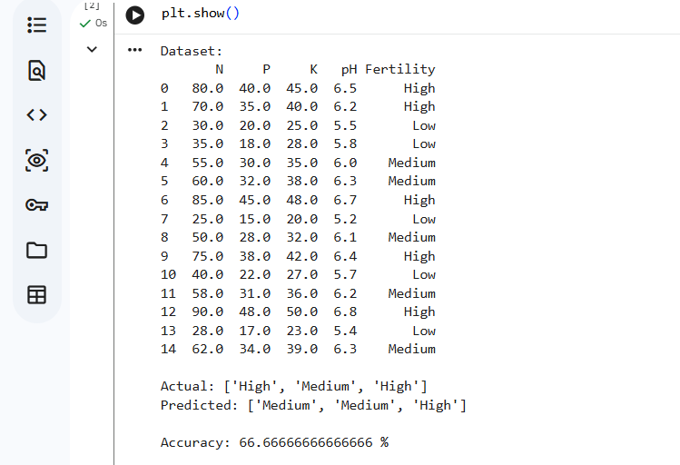
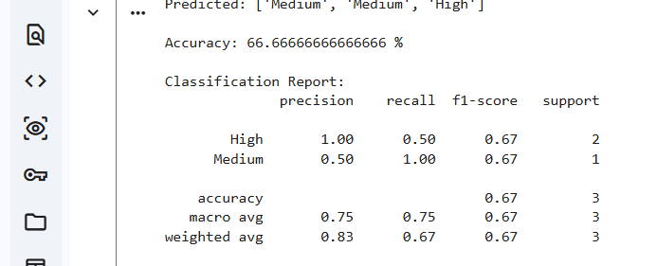
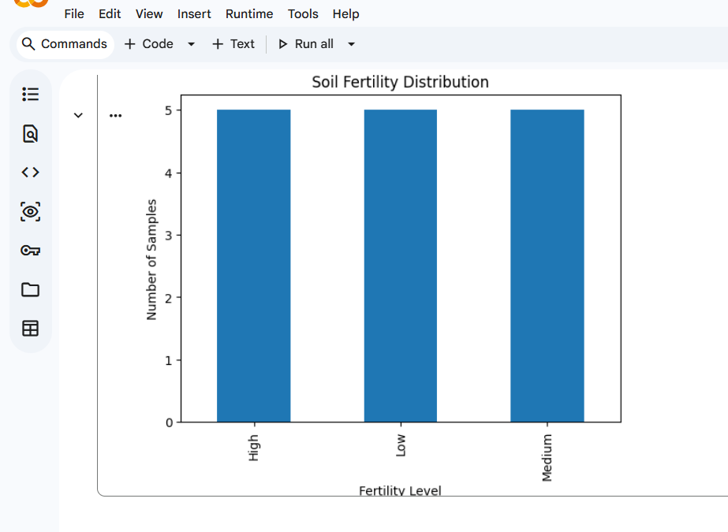
17. Exploratory Data Analysis:
Exploratory Data Analysis is performed to understand the characteristics of the dataset.
17.1 Fertility Class Distribution
The number of observations belonging to each fertility class is calculated using:
data["Fertility"].value_counts()
The result is visualized using a bar chart.
Interpretation
The bar chart shows the distribution of Low, Medium and High fertility soil samples. It helps identify whether the dataset contains a balanced or imbalanced distribution of fertility classes.
18. Model Evaluation:
The KNN model is evaluated using classification metrics.
18.1 Accuracy
Accuracy represents the proportion of correctly classified samples.
[
Accuracy =
\frac{Correct\ Predictions}{Total\ Predictions}
]
The Python implementation uses:
accuracy_score(y_test, y_pred)
19. Precision:
Precision indicates how many of the samples predicted as a particular class were actually members of that class.
[
Precision =
\frac{TP}{TP+FP}
]
A higher precision indicates fewer false-positive predictions.
20. Recall:
Recall measures how effectively the model identifies actual samples belonging to a particular class.
[
Recall =
\frac{TP}{TP+FN}
]
A higher recall means that the model identifies more of the actual samples correctly.
21. F1-Score:
F1-score combines precision and recall.
[
F1 =
2\times
\frac{Precision\times Recall}
{Precision+Recall}
]
It is useful when evaluating classification performance across different classes.
22. Classification Report:
The classification report generated by the program contains:
- Precision
- Recall
- F1-score
23. Results:
The KNN algorithm was successfully implemented for classifying soil fertility levels.
The model uses:
- Nitrogen
- Phosphorus
- Potassium
- pH
as input features.
The output is one of the soil fertility categories:
- Low
- Medium
- High
The model performance is evaluated using accuracy, precision, recall and F1-score.
24. Actual Vs Predicted Values:
The model predictions are compared with actual test values.
Example format:
Sample | Actual | Predicted
1 | High | High
2 | Low | Low
3 | Medium | Medium
4 | High | Medium

Interpretation
If actual and predicted values are the same, the model has correctly classified the soil sample. Differences between actual and predicted values represent incorrect classifications.
25. Result Interpretation:
The KNN model uses the similarity between soil samples to determine fertility categories. Since KNN is based on distance, feature scaling is important before model training.
The model evaluates the soil characteristics of a test sample and compares them with training samples. The fertility category is determined based on the nearest neighbouring observations.
A higher accuracy indicates that the model correctly classifies a larger proportion of soil samples. Precision, recall and F1-score provide additional information about the model's performance for individual fertility classes.
The results demonstrate that machine learning can be used as a decision-support approach for soil fertility classification.
26. SDG-Based Recommendations:
The project supports SDG 2 – Zero Hunger through data-driven agricultural analysis.
Recommendation 1 – Soil Testing
Farmers can regularly test soil parameters such as nitrogen, phosphorus, potassium and pH.
Recommendation 2 – Targeted Fertilizer Application
Fertilizer application can be adjusted according to the identified soil condition rather than applying the same amount to all fields.
Recommendation 3 – Monitoring Low-Fertility Areas
Areas classified as Low fertility can be monitored and improved using appropriate soil management practices.
Recommendation 4 – Sustainable Agriculture
Machine learning can support data-driven agricultural decision-making and contribute to sustainable crop production.
Recommendation 5 – Digital Agriculture
The KNN model can be integrated with soil sensors and mobile applications to provide real-time soil fertility information.
27. Real-World Applications:
The proposed system can be applied in:
- Precision agriculture
- Smart farming
- Soil monitoring
- Fertilizer recommendation
- Agricultural decision-support systems
- Crop planning
- Digital agriculture
- Soil quality monitoring

28. Advantages:
The proposed KNN approach has several advantages:
- Simple to implement.
- Easy to understand.
- Suitable for classification.
- Can classify new soil samples.
- Uses multiple soil characteristics.
- Requires relatively simple preprocessing.
- Can be integrated into agricultural decision-support systems.
29. Limitations:
Some limitations of the proposed system are:
- KNN can become computationally expensive for very large datasets.
- The choice of K can affect model performance.
- Feature scaling is important.
- Noisy data can affect predictions.
- Imbalanced classes can affect classification performance.
- Soil fertility depends on additional factors that may not be included in the dataset.
- The model should be validated using larger real-world agricultural datasets before practical deployment.
30. Future Enhancement:
The project can be improved in several ways.
30.1 Larger Dataset
A larger soil dataset containing samples from different agricultural regions can be used.
30.2 IoT Sensors
Soil sensors can collect real-time values of moisture, nutrients and pH.
30.3 Crop Recommendation
The system can be extended to recommend suitable crops based on soil conditions.
30.4 Fertilizer Recommendation
The model can be combined with fertilizer recommendation techniques.
30.5 Comparison with Other Algorithms
KNN can be compared with:
- Decision Tree
- Random Forest
- Support Vector Machine
- Logistic Regression
30.6 Mobile Application
The system could be developed as a mobile application where farmers enter soil parameters and receive a predicted fertility category.
31. Innovation:
The major innovation of the project is the application of a simple machine learning classification algorithm to an agricultural problem related to food security.
The proposed system can transform soil measurements into an understandable fertility classification. This can support farmers in making data-driven decisions.
A future system can combine:
Soil Sensors + Machine Learning + Mobile Application + Crop Recommendation
to create a smart agriculture decision-support system.
32. Conclusion:
This project successfully demonstrates the application of the K-Nearest Neighbour machine learning algorithm for soil fertility classification. Soil parameters such as nitrogen, phosphorus, potassium and pH are used as input features, while fertility level is used as the target variable.
The dataset is preprocessed to handle missing values, and the input features are standardized before applying KNN. The dataset is divided into training and testing sets, and the KNN model is trained using the training data. Predictions are generated for unseen test samples and evaluated using accuracy, precision, recall and F1-score.
The results demonstrate the potential of KNN for classifying soil fertility based on soil characteristics. Such a system can support agricultural decision-making by identifying soil conditions and encouraging appropriate soil management practices.
The project is strongly connected with SDG 2 – Zero Hunger, because improving soil management and agricultural productivity can contribute to food security and sustainable agriculture. Future improvements can integrate real-time sensors, larger datasets and crop or fertilizer recommendation systems.

33. References:
- Cover, T. and Hart, P., “Nearest Neighbor Pattern Classification,” IEEE Transactions on Information Theory, 1967.
- Han, J., Kamber, M. and Pei, J., Data Mining: Concepts and Techniques, Morgan Kaufmann.
- Scikit-learn Documentation, K-Nearest Neighbors Classification.
- McKinney, W., Python for Data Analysis, O'Reilly Media.
- NumPy Documentation, Numerical Computing with Python.
- Pandas Documentation, Python Data Analysis Library.
- Matplotlib Documentation, Python Visualization Library.
- United Nations, Sustainable Development Goals – Goal 2: Zero Hunger.

